**Assessment 4**

Class - 4

Email address:

Write your name:

1. A while loop in Python is used for what type of iteration?

(2 points)

* Indeterminate
* Discriminant
* Indefinite
* Definite

**2.** What will be the output of this code? (3 points)

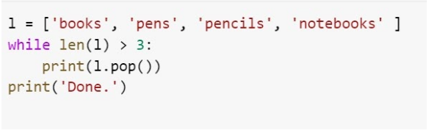

* Option 1

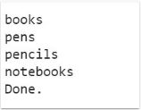

* Option 2

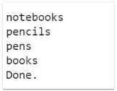

* Option 3

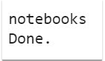

* Option 4



**3.** What will be the output of this code? (3 points)

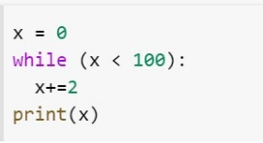

* 101
* 99
* None of these, cause it's an infinite loop
* 100

4. What will be the output of this code? (3 points)

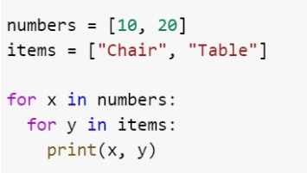

* Option 1

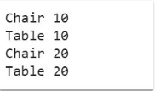

* Option 2

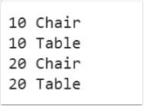

* Option 3

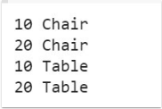

* None of these

**5.** What will be the output of this code? (4 points)

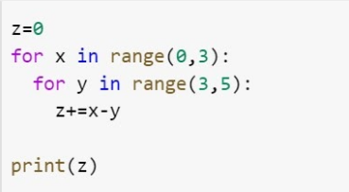

* 18
* -25
* -10
* -15